Authorized signatories by type of company
Guide
Contract Validation Center
10/26/2022

This document is intended as a reference for all departments that have to have contractual documentation signed by external clients. More specifically how to determine who has signing authority based on the type of company and the province of our client in order to obtain valid documentation.

Table of content
Purpose 2
Revision history 2
Impacted Departments 2
General Points 3
1. Joint stock company (“Inc.”) 3
a. Non-profit company 4
2. Sole proprietorship 4
3. General Partnership (G.P.) – Quebec only 5
a. Limited Liability Partnership (“L.L.P.”) 5
4. Limited Partnership (“L.P.”) 6
5. Société en participation (« S.E.P. ») Joint Venture Partnership? 6
6. Cooperative 6
7. Municipality 7
8. Non-profit Organization (“NPO”) 7
9. “Partnership” (ROC only) 8
Appendix I – Visio Unanimous shareholder agreement 9
Appendix II – Definitions REQ 10
Appendix III – Excerpt from the City Council meeting resolution 11

Purpose
Develop a Guide describing the authorized signatories according to the type of company in the contract.

Revision history

12/01/2022 1.0 Creation

Impacted Departments
- Contract Validation Center
- Legal
- Customer Service
- Transfers
- Sales
- Sales Support
- Credit

General Points
- The responsibility for establishing the correct signatory rests first with Credit when accepting the application and integrating the datas in Vision. Then to the person who document the contract (Sales, Sales Operation, Legal). When the contract is documented externally by a partner (Broker or Syndication), we must validate the information at V1 stage and V2.

Joint stock company (“Inc.”)

CONCEPT | - Legally constituted company with distinct patrimony which can enter into contracts, hold assets and incur debts.  - Owned by one or more shareholders but administered by one or more directors  - Incorporated under provincial (Quebec Inc.) or federal (Canada Inc.)  - Unless there is a personal guarantee, the shareholders are not liable for the debts of the company
WHO CAN SIGN | One or other of the directors appointed to the REQ/Securfact
EXCEPTION | Presence of a unanimous shareholder agreement:  - The risk is that the signing authority of directors has been withdrawn and assigned to shareholders  - The REQ indicates the existence of this agreement. In the ROC it is up to the customer to notify us, the Securfact does not indicate this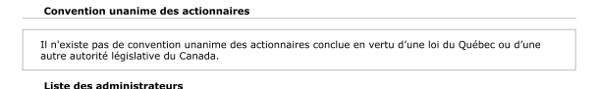  - Procedure on page 52 of the Credit Risk Policy: http://intranet/sites/Canada/en-ca/doccenter/Policies/MHCCA-MHCCL%20Credit%20Risk%20Policy.pdf#search=risk%20policy  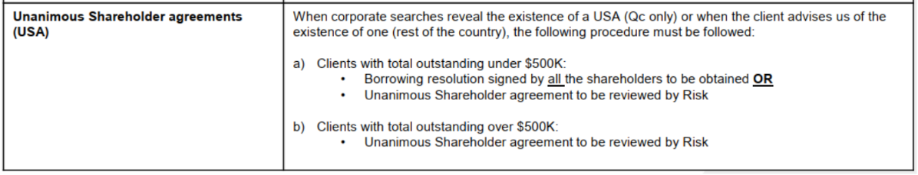  - See Appendix I for detailed procedure: Appendix 1 – Visio Unanimous Shareholder Agreement
EXCEPTION | Power of attorney or signature resolution provided to authorize a third party to sign  External document that must be approved by credit, legal or a CVC manager

Non-profit company
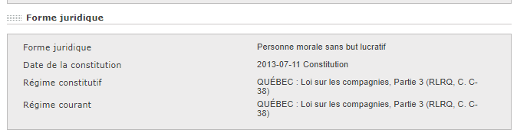

  - Request a Board Resolution signed by the President or Secretary (CON14.21/CON14.22)

Sole proprietorship

CONCEPT | - Self-employed: simple and inexpensive form.  - Not distinct from its owner, same inheritance  - Only one owner  - No legal obligation to be registered with the REQ/Securfact, on the other hand we require it to demonstrate that we are indeed financing a company and not a physical person.
WHO CAN SIGN | The owner
REQ | Refer to the section "Nom" - "Nom de la personne physique"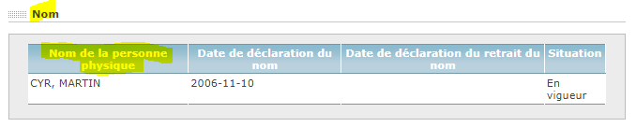
SECURFACT | Rely on the “Proprietor information” section  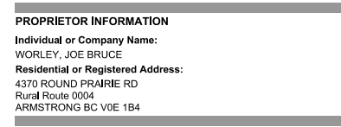

General Partnership (G.P.) – Quebec only

CONCEPT | - A group of people (referred to as “partners”) who have decided to carry out a common activity (e.g. offering legal or accounting services).  - Each partner is personally liable for the debts and acts of the company
WHO CAN  SIGN | All the associates must sign and provide a valid ID
REQ | Refer to the “Associates” section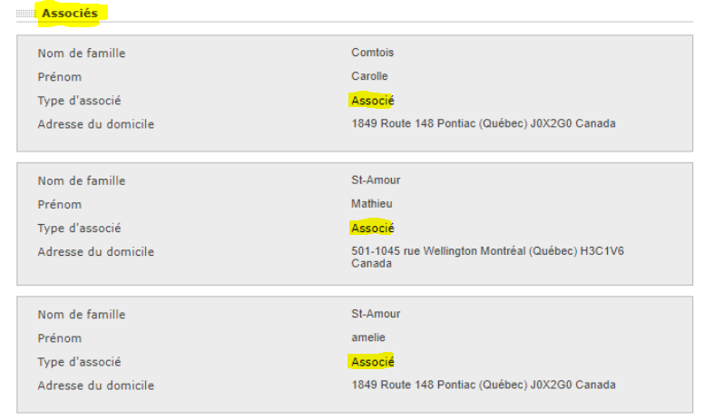

Limited Partnership (“L.P.”)

CONCEPT | - Company where the partners are divided into 2 categories: the sponsors and the sponsored.  - Sponsor: Contributes with a financial contribution in order to receive dividends but does not manage the company.  - Personally responsible for the debts of the company up to the amount of their financial contribution.  - Sponsored : Contributes by providing expertise and manages the business.  - Personally responsible for the debts of the company
WHO CAN  SIGN | One of the sponsored  N.B. a limited partner (sponsor) has no signing authority

Société en participation (« S.E.P. ») Joint Venture Partnership?

CONCEPT | - Rather rare, it is in fact a business relationship between partners that is then called a partnership. Very informal.  - No legal obligation to register, but we require it to finance.  - No separate assets of its partners
WHO CAN  SIGN | All associates must sign and provide valid ID

Cooperative

CONCEPT | - Legal person bringing together people or companies that have common economic, social or cultural needs and that associates to operate a business.  - A cooperative has 2 structures  - Structure of association of people that functions in a democratic way (general meeting and board of directors) o Corporate structure (general management, administrative departments, secretariat, employees, etc.)  - The cooperative is governed on behalf of the members by the board of directors and is managed by a person appointed by the same board (General Manager)  - The cooperative is governed on behalf of the members by the board of directors and is managed by a person appointed by the same board (General Manager)  - It belongs to all its members equally. It is a company whose co-owners are the users (“members”)
WHO CAN  SIGN | Everything will depend on what the internal documents of the cooperative mention. This is why we must ask the customer to provide us with:  - Extract from a resolution of a verbal process naming the authorized signatories;  - The Cooperative's Certificate of Conformity;  - The regulations of the internal management of the Cooperative  Then have the legal team validate it to determine who has signing authority.

Municipality

CONCEPT | - Each municipality has a municipal council composed of a mayor and several councillors, the number of which varies according to the size of the city.  - Territory over which a local authority is exercised in accordance with municipal laws
WHO CAN  SIGN | Administrator at the REQ or signatory designated via an Extract from the resolutions of a council meeting of the Municipality (see example Appendix III)

Non-profit Organization (“NPO”)

CONCEPT | - Non-profit organizations are associations, clubs or societies which are not charities and which are established and operated solely for the purposes of community welfare, local improvements, recreation, entertainment or any other non-profit activity.  - No obligation to register under the REQ/Securfact  - Examples :  - Social, recreational or leisure groups (bridge, curling and golf clubs)  - Amateur sports organizations (hockey associations, baseball leagues, soccer)  - Some festival organizers (parades and seasonal celebrations)
WHO CAN  SIGN | Administrator at the REQ or signatory designated via an Excerpt from the resolutions (our form or the client’s)

CON 14.21 (Excerpt from Board resolutions) | Resolution provided by the customer
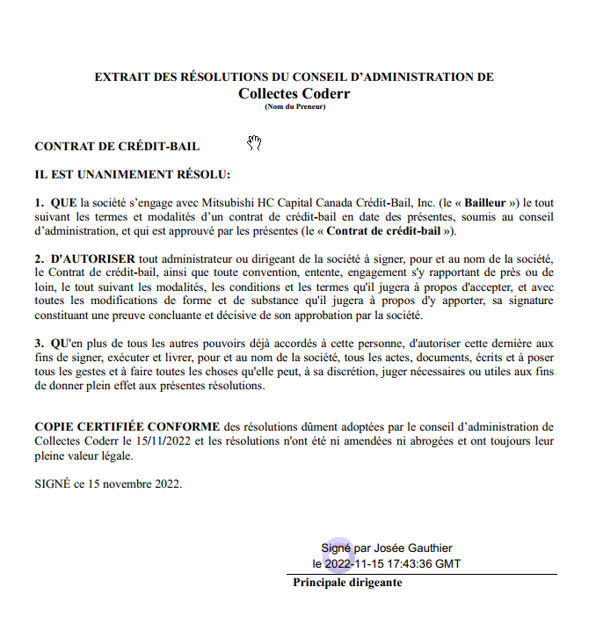 | 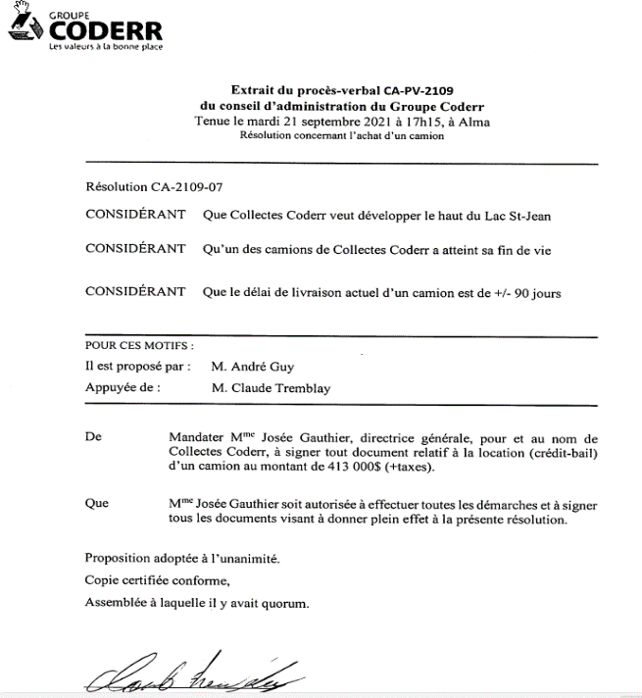

“Partnership” (ROC only)

CONCEPT | - Form of business where at least 2 people share the ownership and management of the business, the losses and the income it generates. On account 3 most frequent types of partnership:  - Limited  - Limited partners see their liability limited to their contribution to the company  - General  - The partners have 100% joint liability of the debts and commitments incurred by the company  - Limited Responsabilities
REFERENCE | Full details on pages 84 and following of the Customer Documentation and Security Policy:  http://intranet/sites/Canada/en-ca/doccenter/Policies/MHCCA-MHCCL%20Documentation%20and%20Security%20Policy.pdf
WHO CAN SIGN | - Partenariat Général  - All the partners must sigh the contract  - Limited partners (Peut-on dire que c’est le même principe qu’une S.E.C.? donc les limited partners c’est comme les commanditaires et les general partners c’est comme les commandités, qui ont le droit de signer?)  - Only the General Partners cans sign the contract (un de ceux-ci ou tous doivent signer?)

Appendix I – Visio Unanimous shareholder agreement

Appendix II – Definitions REQ

Actionnaires, administrateurs, dirigeants et fondé de pouvoir (shareholders, directors, officers and attorney)
Actionnaires (shareholders) | Natural or legal persons who hold one or more shares issued by a business corporation.  The three shareholders who hold the most votes are indicated.
Convention unanime des actionnaires (unanimous shareholder agreement) | One of the following three messages is displayed:  “Il existe une convention unanime des actionnaires." (There is a unanimous shareholder agreement.)  "Il n’existe pas de convention unanime des actionnaires." (There is no unanimous shareholder agreement.)  “Il n’existe plus de convention unanime des actionnaires." (There is no longer a unanimous shareholder agreement.)
Actionnaires ou tiers assumant les pouvoirs du conseil d’administration (shareholders or third parties assuming the powers of the board of directors) | When all the powers have been removed from the board of directors by a unanimous shareholder agreement, the enterprise must declare the list of shareholders or third parties assuming these powers.  In addition, the history of the shareholders or third parties who assumed the powers of the enterprise’s board of directors is displayed in this section.
Liste des administrateurs (list of directors) | List of the enterprise’s directors  In addition, the history of the enterprise’s former directors is displayed in this section.
Dirigeants non membres du conseil d’administration (officers who are not members of the board of directors) | Persons who are involved in the general administration of the enterprise but who are not members of the board of directors.

Appendix III – Excerpt from the City Council meeting resolution

